In the hostname with kubernetes & flannel netowkring installed :

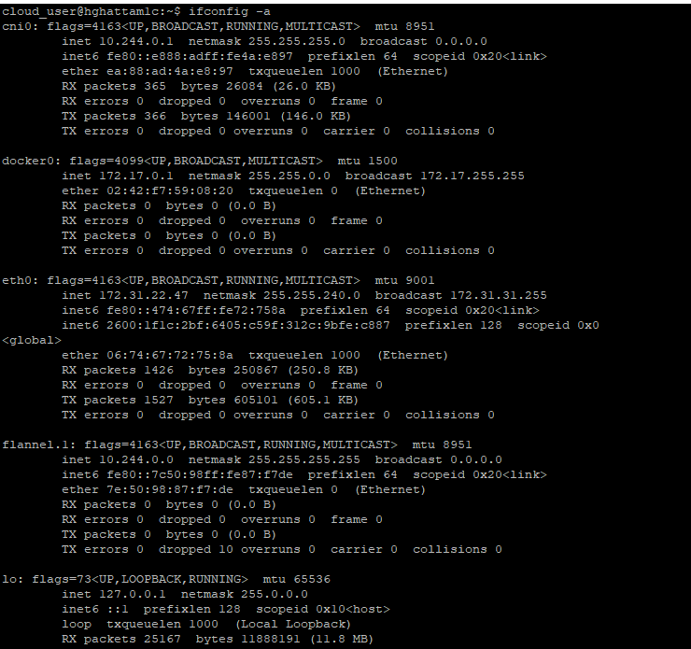

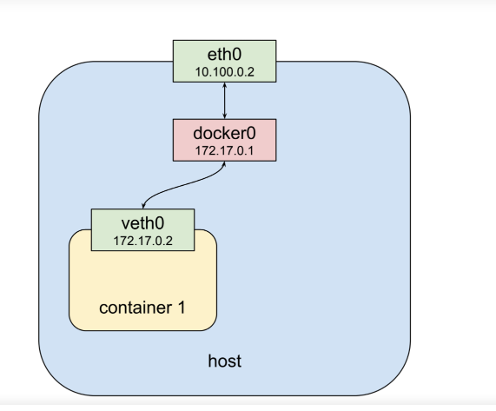

Kubernetes pod networking:

Nodeport – 30000 – 32767

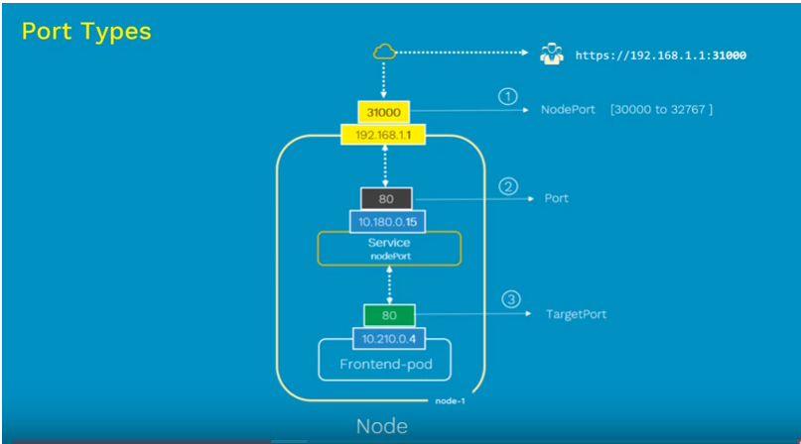

1. NodeIP
2. PORT which is service
3. Target Port which is the container

Note: port and target are mostly same

How to check or query dns names of pod:

1. Run busybox image

apiVersion: v1

kind: Pod

metadata:

name: busybox

spec:

containers:

- image: busybox:1.28.4

Command:

- sleep

- "3600"

name: busybox

restartPolicy: Always

1. After running Nginx image.
2. We can execute commands in container using exec command:

Kubectl exec busybox -- nslookup Nginx

Kubernetes rollout deployment strategies:

1. Initiate the deployment

apiVersion: apps/v1

kind: Deployment

metadata:

name: threads

spec:

replicas: 3

selector:

matchLabels:

app: threads

template:

metadata:

name: threads

labels:

app: threads

spec:

containers:

- image: hemanth224/threads

name: app

1. kubectl apply -f threads.yaml --record (use the record option to the record the deployment/ save the changes)
2. kubectl rollout history deployment threads
3. you can check the image which has been deployed

kubectl describe deployment threads

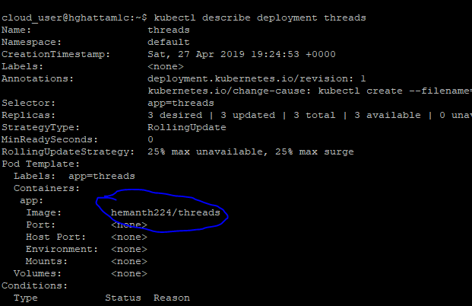

1. now switching to newer version

kubectl set image deployments/threads app=hemanth224/threads:v1

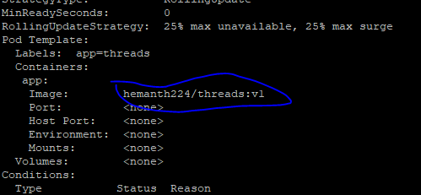

1. roll out to previous version

kubectl rollout history deployment threads

kubectl rollout undo deployment.extensions/threads --to-revision=1

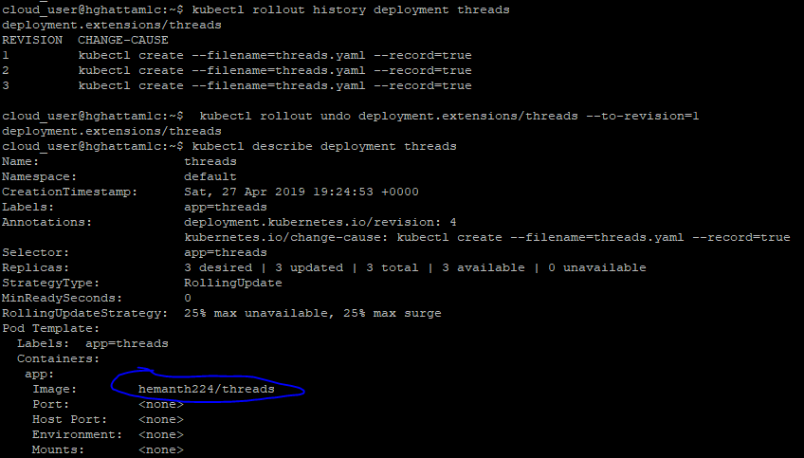

Checking the desired state:

